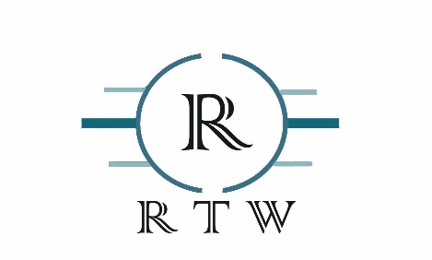
Brand Guide: Robin Tyler White.

Brand Overview:
The vision of the logo design is to brand me as an individual to be recognized by my target audience locally as well as on a global scale.
Secondary Logo:


Social Profile Icon and Website Favicon:

Fonts used in Logo:
Colonna MT
1234567890
ABCDEFGHIJKLMNOPQRSTUVWXYZ
!@#$%&.?-
| Colors | RGB | CMYK |
R:58 | B:132 | G:113 C:80| M:45| Y:37| K:10
Blue
| Colors | RGB | CMYK |
R:0 |B:0 |G:0 C:75| M:68 | Y:67 | K:90
Black

